**IMAGE RECOGNITION WITH IBM CLOUD VISUAL RECOGNITION**

**Image recognition setup:**

IBM Watson Visual Recognition is a tool that uses deep learning algorithms to analyze images and allow users to automatically identify subjects and objects contained within the image and organize and classify these images into categories.

To create an IBM Cloud account, set up the Visual Recognition service, and obtain API keys, following steps are followed

**Prerequisites:**

1. IBM Cloud account (A credit card is NOT required to sign up for IBM Cloud Lite account and there is no charge associated in creating a Lite plan instance of the Watson Discovery service).
2. Device with good internet connection.

**Procedure**

**Step 1**: Create an IBM Cloud Account

Use the link given to sign up or login to IBM cloud. <https://cloud.ibm.com/registration>.

**Step 2**: Confirm Your Email Address

An email is sent to your email address to confirm your account. Go to your email account, and click on the “Confirm Account” link in the email that was sent to you.

**Step 3**: Login to Your Account

**Step 4**: Create a New Resource

On your dashboard page, click on the Create a resource on the top right to create a new source.

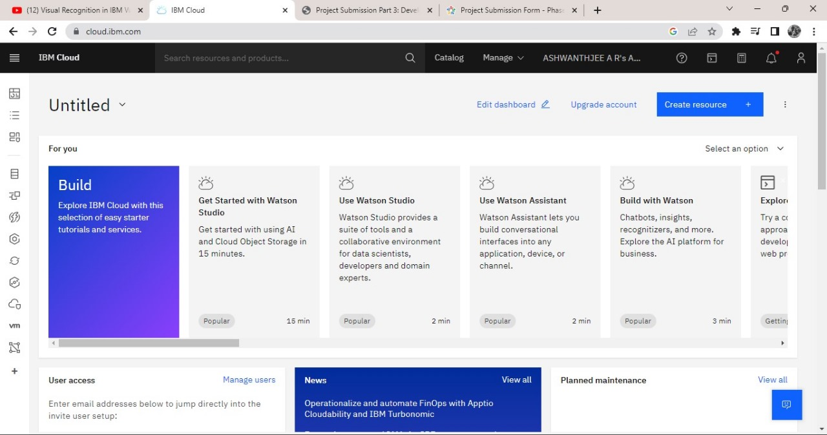

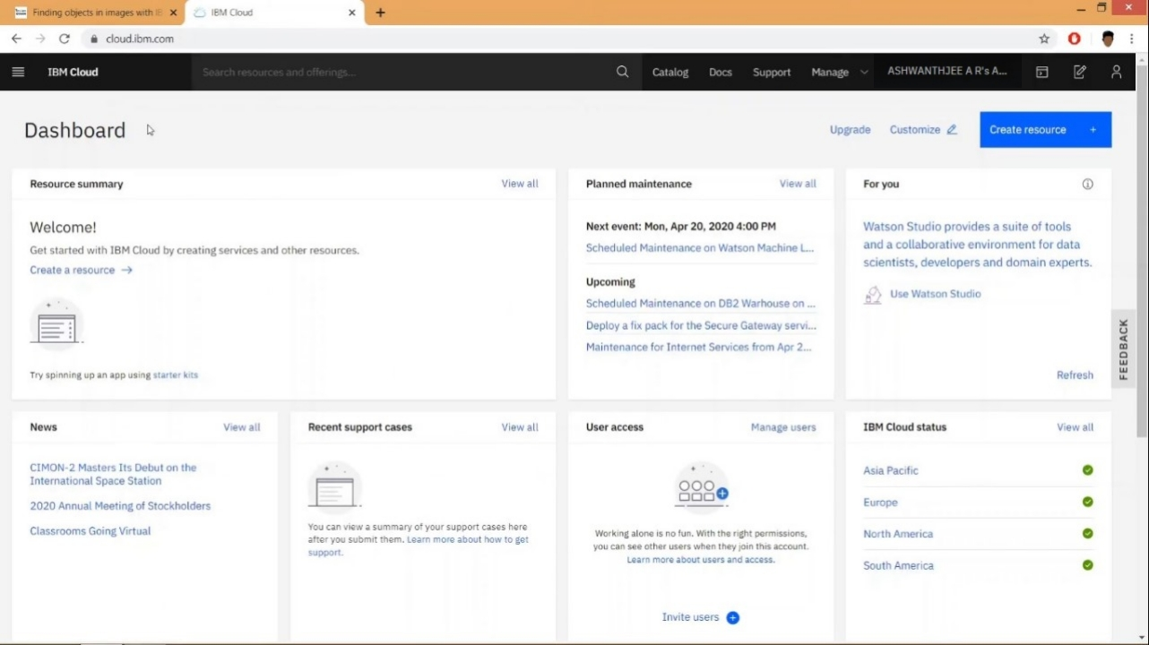

**Step 5**: Create a Visual Recognition and Watson Studio Resource

On the Catalog page, select the AI category from the left pane, and then select the Watson Studio resource.

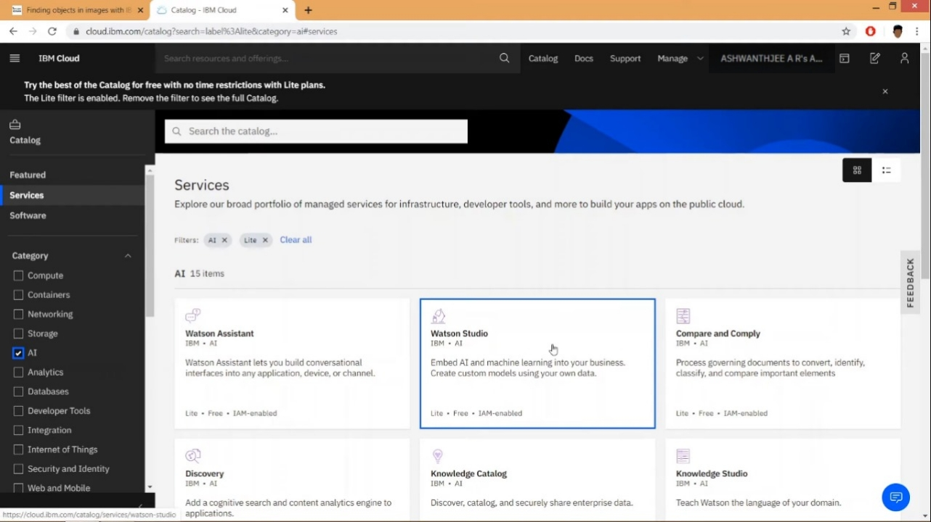

On the next page, you will get to name your service instance and choose your region. Click on the arrow to reveal the drop-down menu of regions. Make sure to select the region that is closest to you. Then scroll down and make sure that the lite plan is selected, and click the Create button.

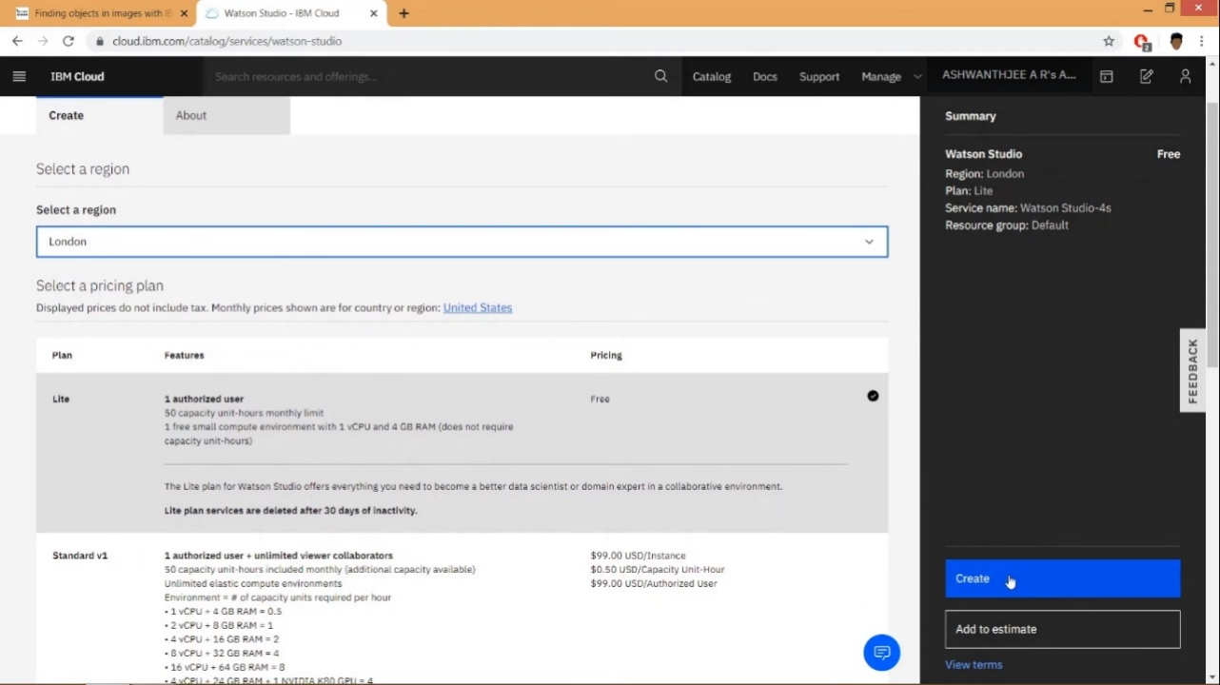

On the next page, click the Get Started button to start using Watson Studio.

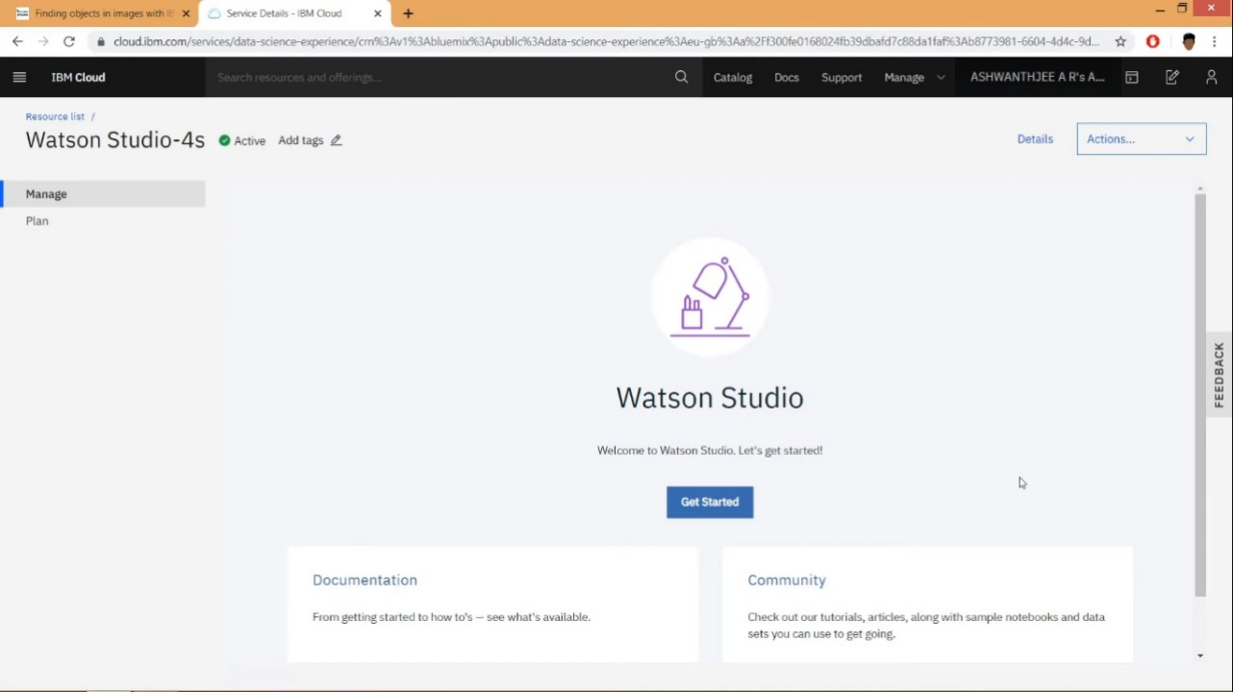

Once the provisioning process is complete, click the Get Started button to start using Watson Studio.

**Step 6**: Create a Project

Once you land on the IBM Watson Studio main page, start by creating a project.

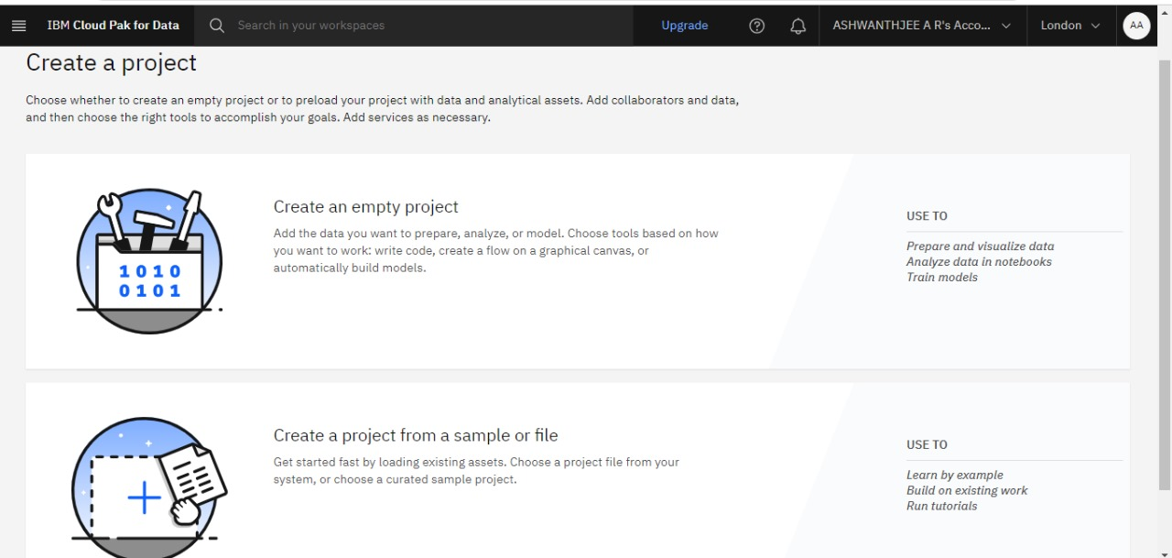

Choose create empty project.

**Step 7**: Set up Your Project

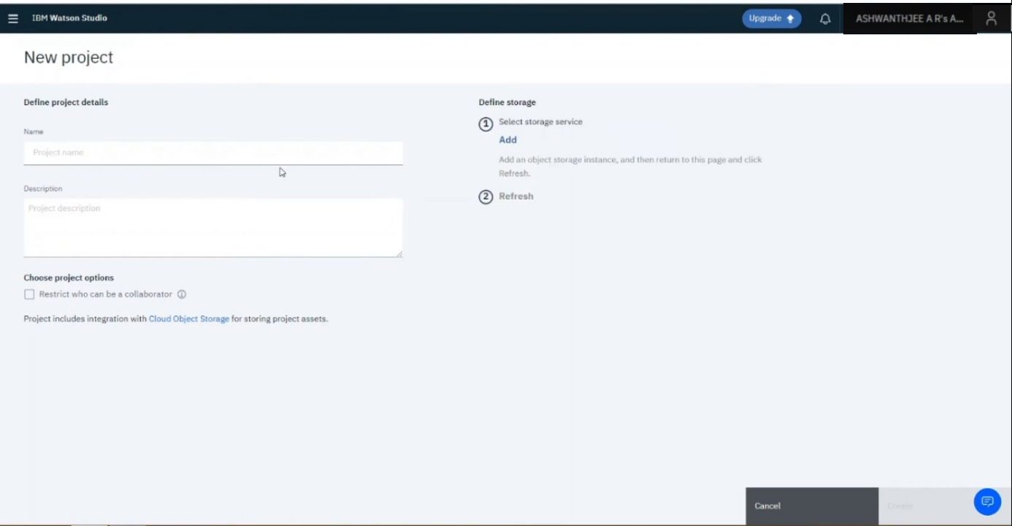

Fill in some project details and click Create. The IBM Cloud Object Storage, which provides you storage for your images, should be automatically created for you but if not created you can click on add button below the heading on top right part of screen. if it is already created it will show you name and will not let you create a new one.

Create the storage service with the lite plan and click on create button. Go to Add to project and choose Image classification.

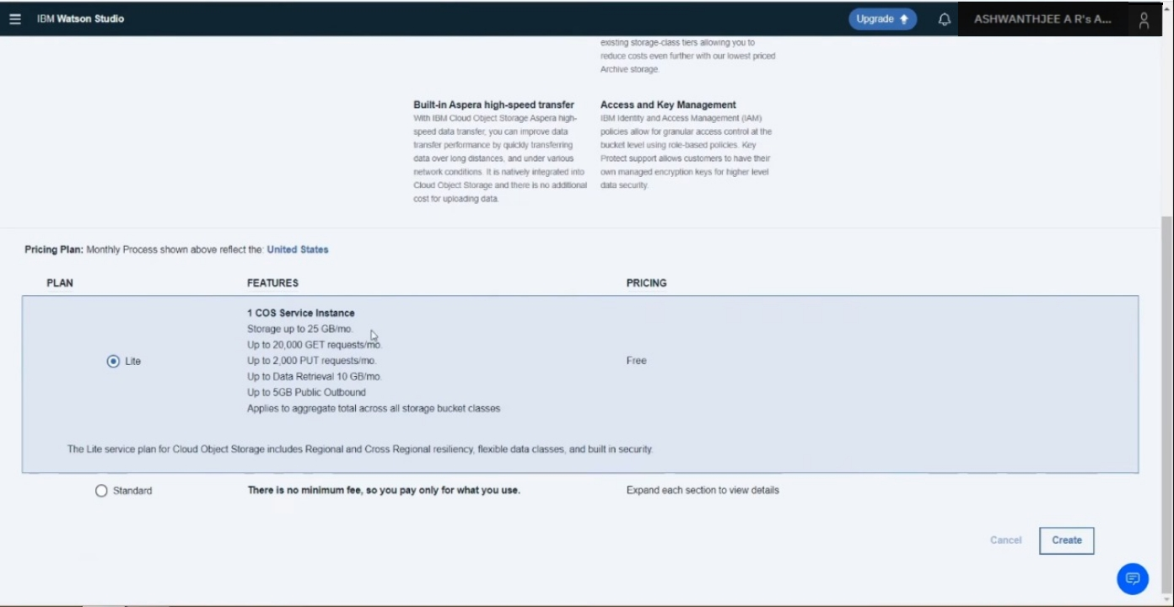

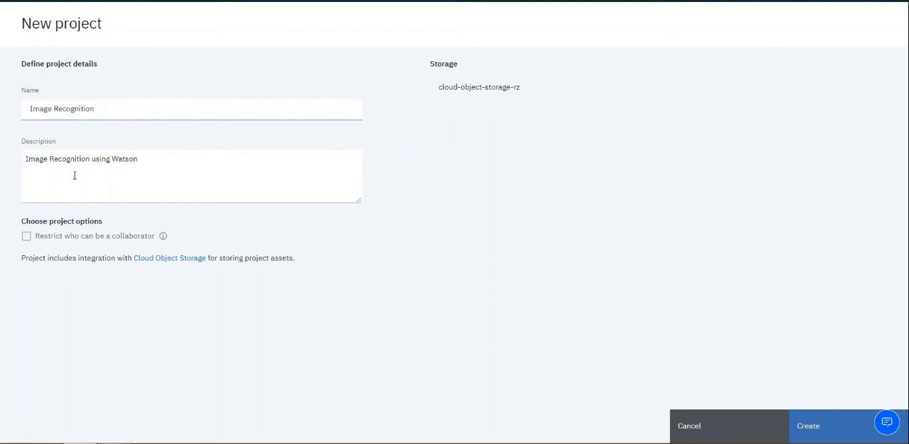

**Add the Visual Recognition to the project**

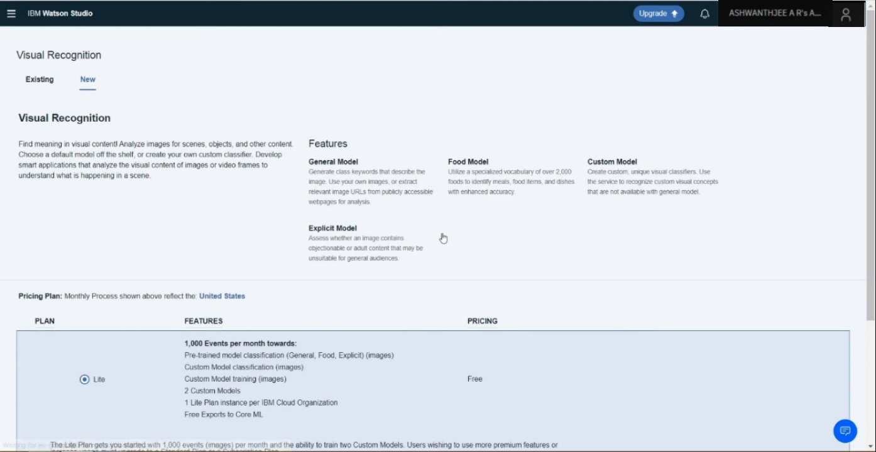

**Step 8: Selecting Built-in Models for Watson Visual Recognition**

After creating your project, by default, you will land on the page where you can perform some advanced tasks but we will skip this for now and use the built-in models. To access the built-in models, click on the name of the service, as seen in the red box below:

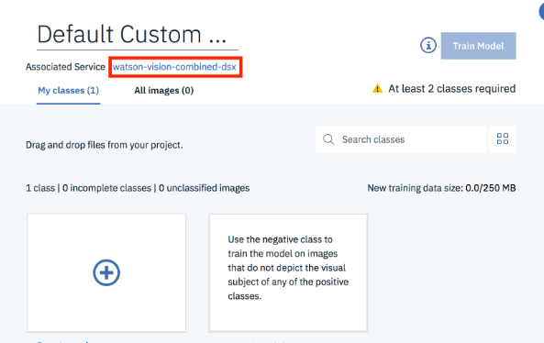

**Step 9**: Choose the General model.

Now you can see all the built-in image classification models that IBM Watson provides! Let’s try the General model.

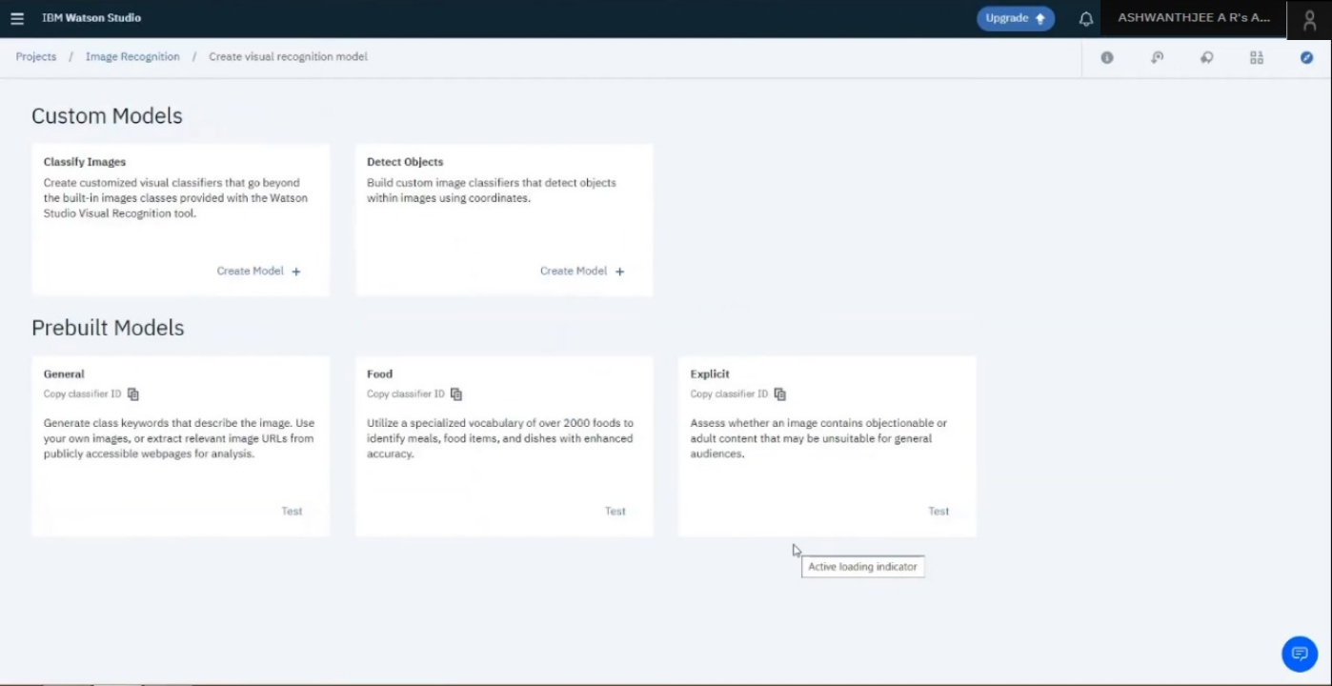

**Step 10**: Try out the General model

To test the General model, click on Test tab on top of screen.

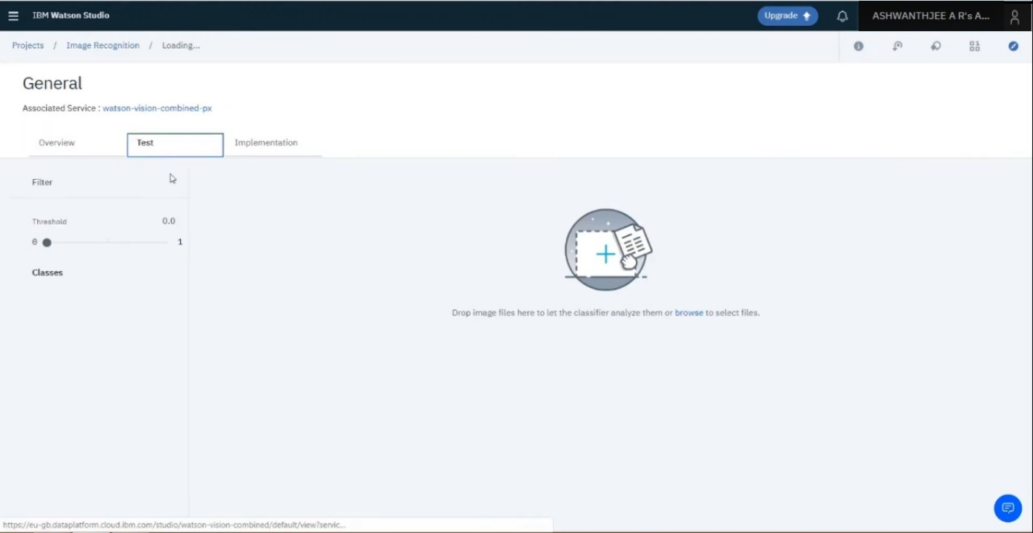

**Step 11**: Upload Your Images

Now you can upload any images you’d like by clicking on Browse. Remember that you will have to upload all the images that you want to test in a single go as once you upload images then you cannot add more images one by one. you will have to go back and upload all images including the new ones.

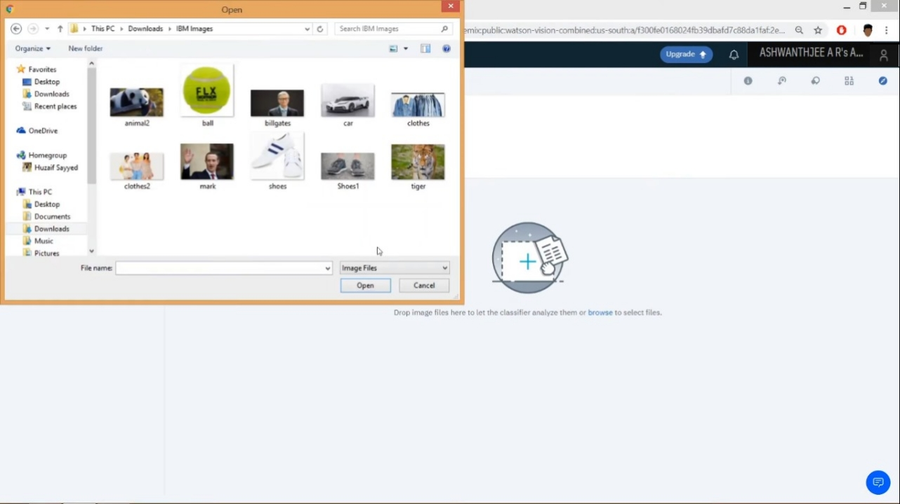

**Step 12**: Check Out the Results!

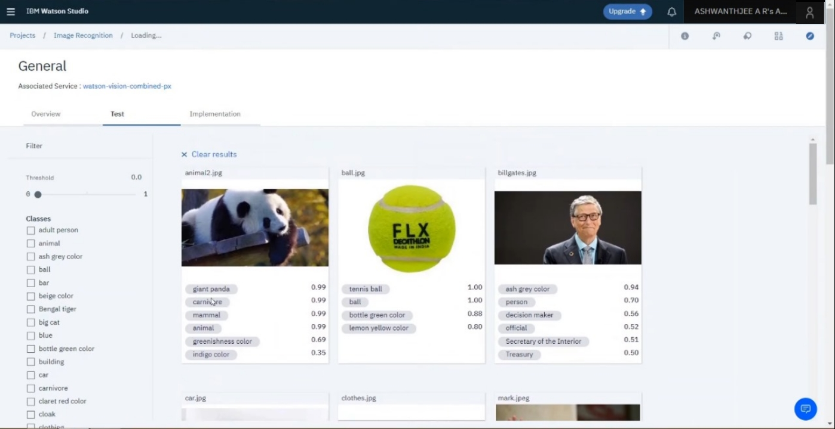

Once you have uploaded your images, it will tell you what it found in your images! Beside each class of object (or color, age, etc.), it will also give you a confidence score (between 0 and 1) on how confident it thinks it found that particular object in your image (0 for lowest confidence and 1 for highest confidence).

**USER INTERFACE:**

To design a simple web interface where users can upload images and view the AI-generated captions.

<!DOCTYPE html>

<html lang="en">

<head>

<meta charset="UTF-8">

<meta name="viewport" content="width=device-width, initial-scale=1.0">

<title>Image Recognition System</title>

<link rel="stylesheet" href="styles.css">

</head>

<body>

<header>

<h1>Image Recognition System</h1>

</header>

<section>

<form enctype="multipart/form-data" action="upload" method="post">

<input type="file" name="image" accept="image/*">

<button type="submit">Upload</button>

</form>

</section>

<section id="result">

<h2>AI-Generated Caption:</h2>

<p id="caption">Waiting for image recognition...</p>

</section>

<footer>

<p>&copy; 2023 Image Recognition System. All rights reserved.</p>

</footer>

</body>

</html>

